**Business Requirements Document for Timetable**

**CRUD Functionally (CREATE, READ, UPDATE, DELETE)**

1. A User can add a module entry to a day of the week with all information entered and it is added to the database for the current day.
2. Entries are displayed to the user when they navigate to a day of the week.
3. The current time is displayed to the user in the view.
4. Entries can be updated when a user clicks on a module.
5. A module entry can be deleted from the application.

View of module for Monday as describe above.

**UWP View:**

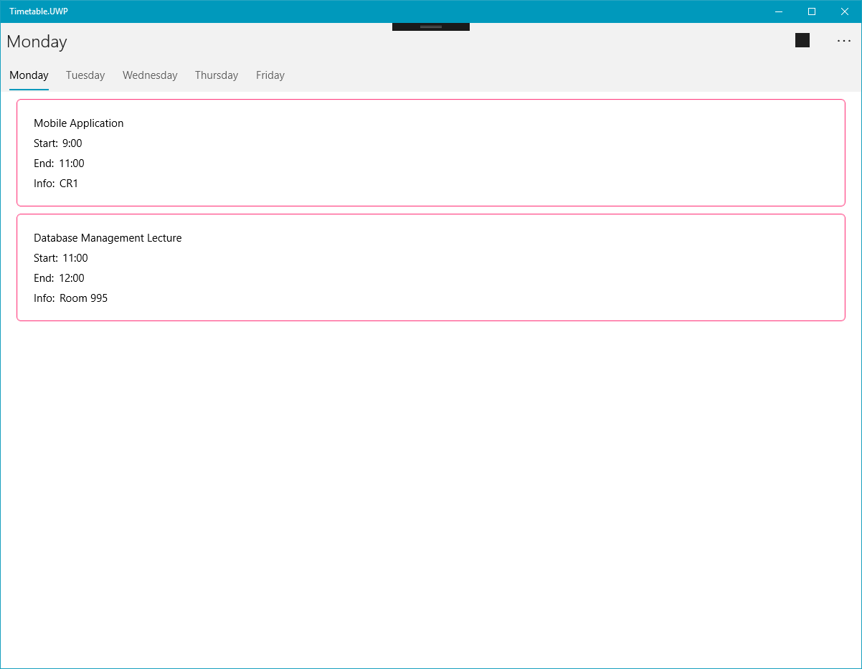

**Android View**

